**DevOps - Assignment 2**

**MCQs:**

**Topic 6: YAML Basics**

1. What does YAML stand for in the context of DevOps?

a. Yet Another Markup Language

b. YAML Ain&#39;t Markup Language

c. Your Application Markup Language

d. Yellow And Magenta Language

Ans: **a. Yet Another Markup Language**

2. In YAML, how is a list of items represented?

a. Using square brackets [ ]

b. Using curly braces { }

c. Using angle brackets < >

d. Using double quotation marks “ “

Ans: **a. Using square brackets [ ]**

**Topic 7: Define and implement continuous integration**

1. What is the primary goal of continuous integration (CI) in DevOps?

a. Automating manual testing

b. Frequent integration of code changes

c. Managing cloud infrastructure

d. Monitoring application performance

Ans: **b. Frequent integration of code changes**

2. Which of the following is a popular CI/CD tool often used in DevOps practices?

a. Docker

b. Kubernetes

c. Jenkins

d. Ansible

Ans: **c. Jenkins**

**Topic 8 & 9 : Get started with Azure DevOps &amp;**

**Build applications with Azure DevOps**

1. What is Azure DevOps primarily used for?

a. Infrastructure management

b. Software development and delivery

c. Network security

d. Virtualization

Ans: **b. Software development and delivery**

2. Which components are part of Azure DevOps?

a. Azure App Service and Azure Functions

b. Azure Monitor and Azure Security Center

c. Azure Boards and Azure Pipelines

d. Azure Virtual Machines and Azure SQL Database

Ans: **c. Azure Boards and Azure Pipelines**

3. In Azure DevOps, what is the purpose of a build pipeline?

a. To create user stories

b. To manage cloud infrastructure

c. To automate the build and test process

d. To monitor server performance

Ans: **c. To automate the build and test process**

4. What is the role of version control in the software development lifecycle?

a. Managing databases

b. Tracking changes in source code

c. Configuring network security

d. Monitoring application performance

Ans: **b. Tracking changes in source code**

**Task Based Exercises:**

**Topic 6 - YAML Basics**

1. Task: Create a YAML file that defines a list of your favorite fruits and their colors.

**Step1**: Create a yaml file inside Lab4.

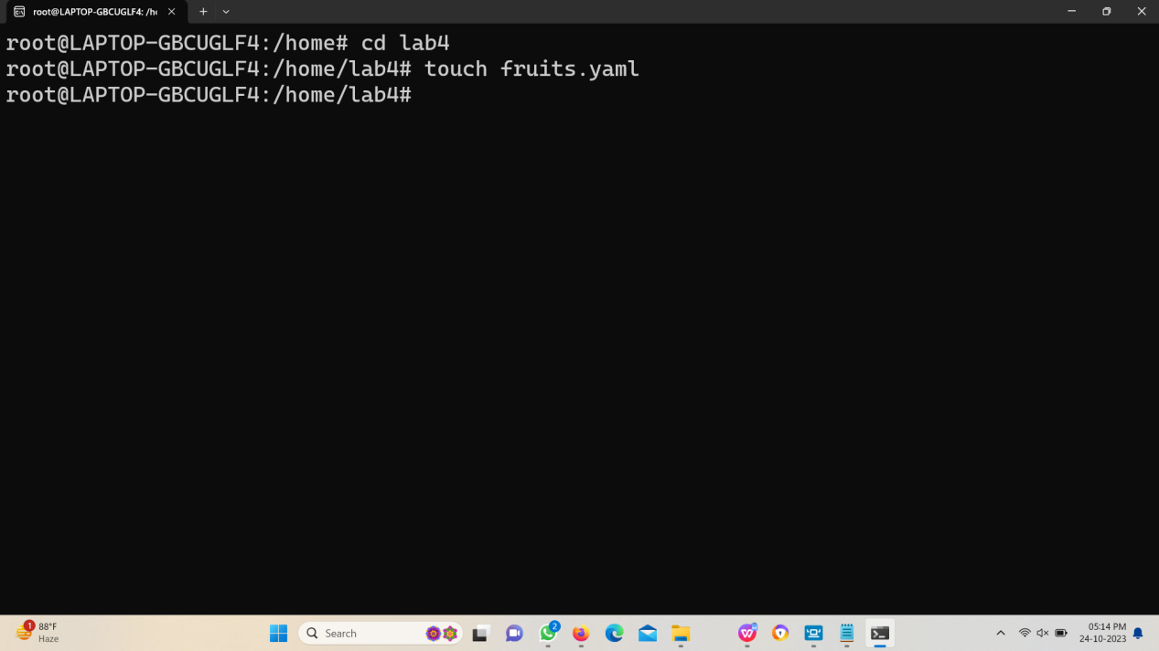

**Step2**: Writing a list inside the yaml file.

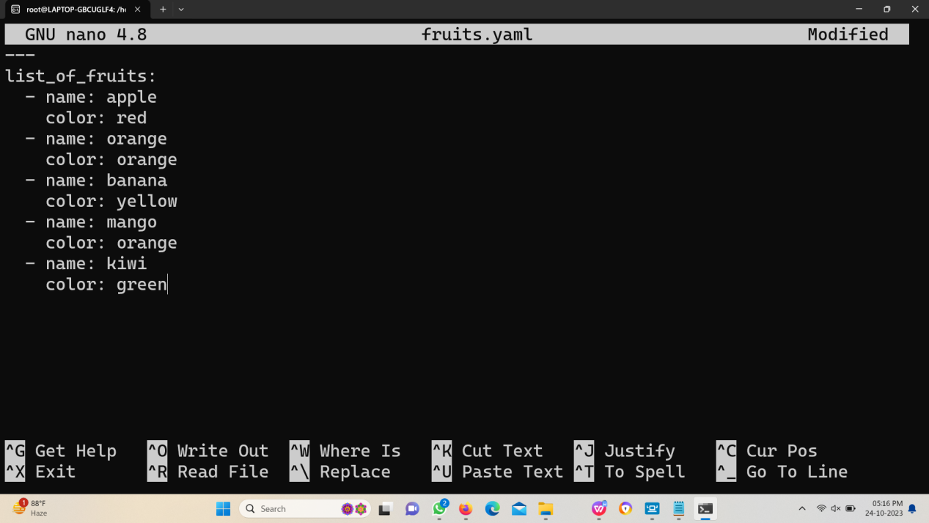

**Step3**: Reading the list inside the yaml file.

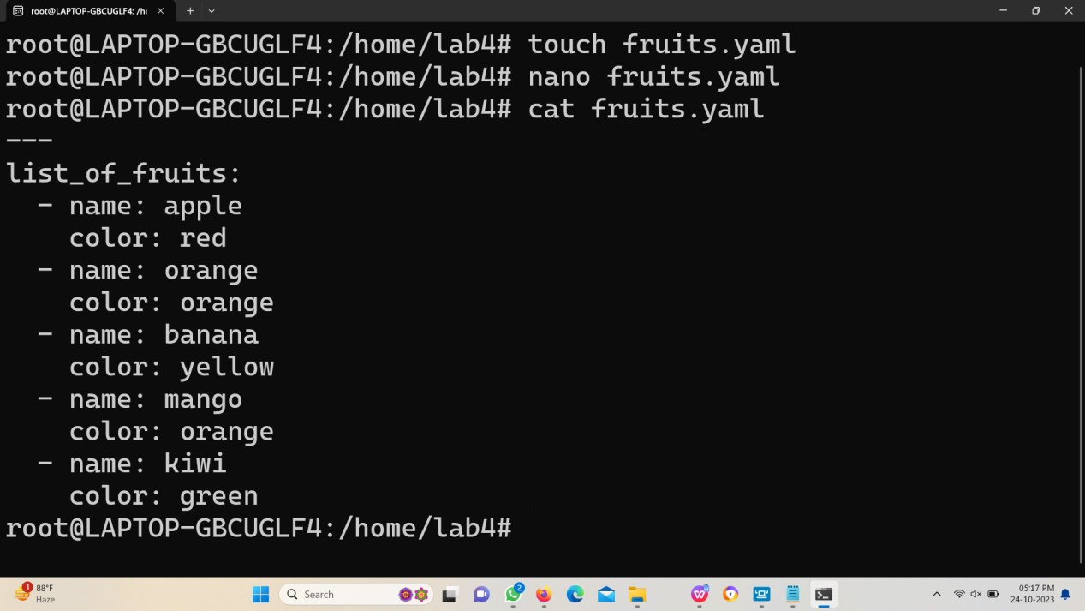

**Step4**: Validating the yaml file.

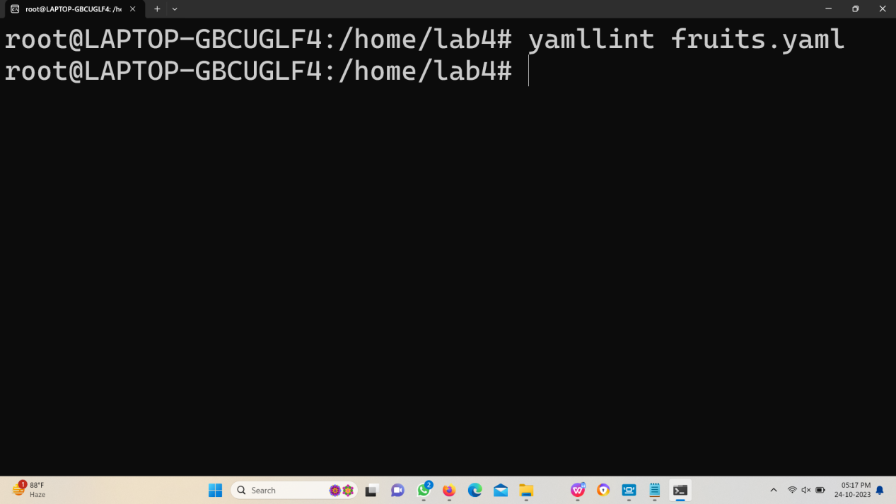

2. Task: Write a YAML configuration for a simple server with properties such as

hostname, IP address, and port.

**Step1**: Create a yaml file inside Lab4.

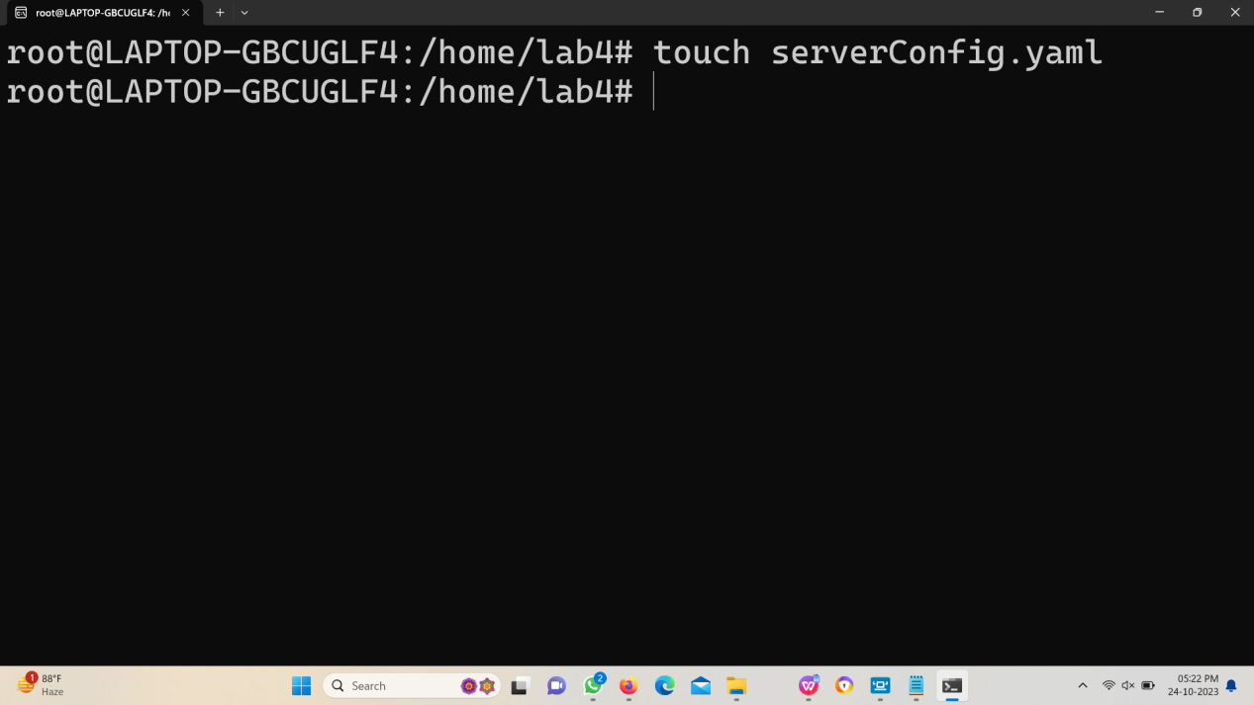

**Step2**: Writing the server configuration in the yaml file.

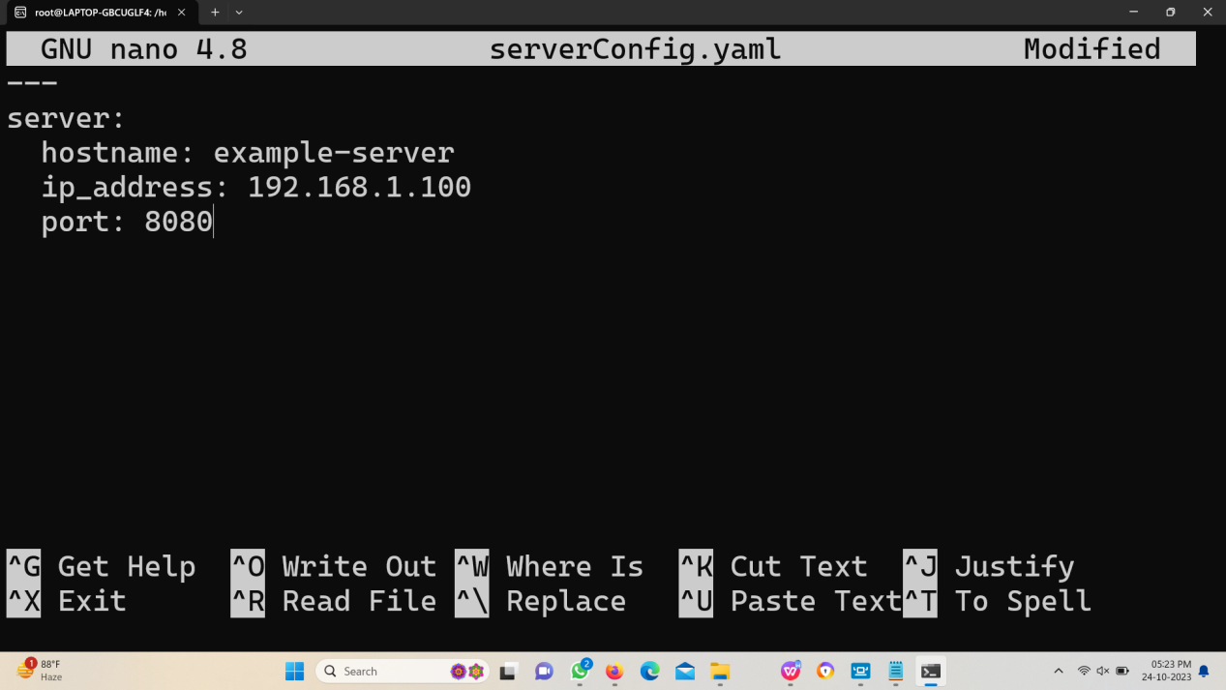

**Step3**: Reading the yaml file using cat command.

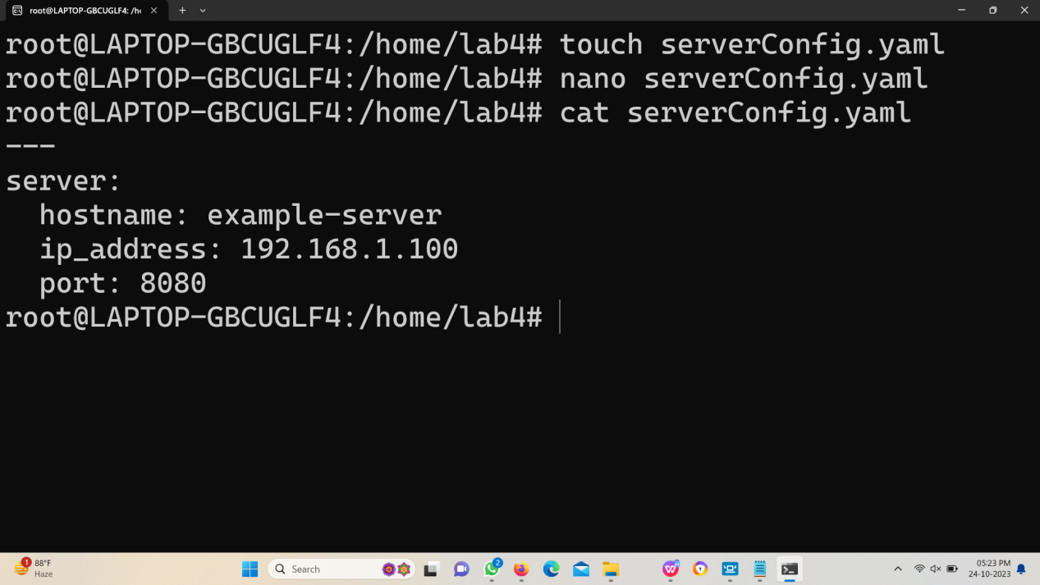

**Step4**: Validating the yaml file using yamllint.

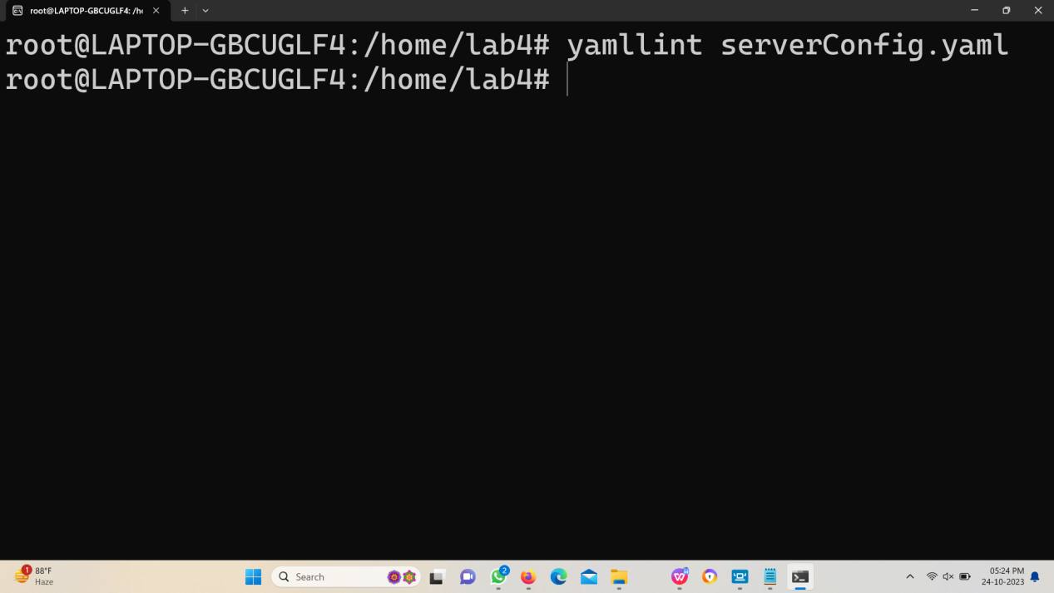

**Topic 7 - Continuous Integration**

1. Task: Set up a basic continuous integration pipeline using Azure Devops.

Step1: Creating a angular project and push it in a azure devops repository.

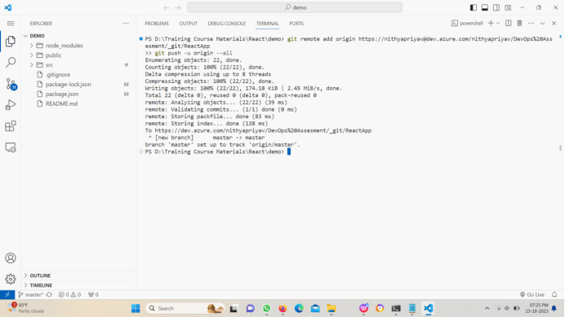

Step2: The angular project files are available in azure devops repository.

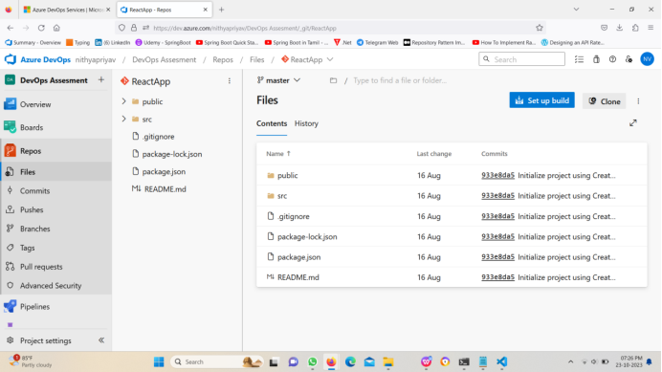

Step3: Creating a new pipeline with npm install, npm build and publish Artifacts.

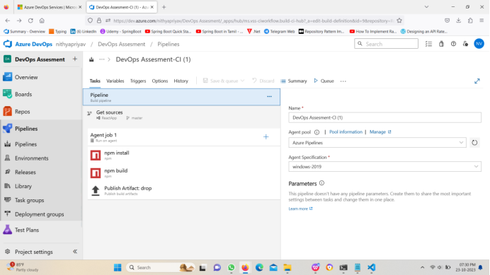

Step4: Running the agent.

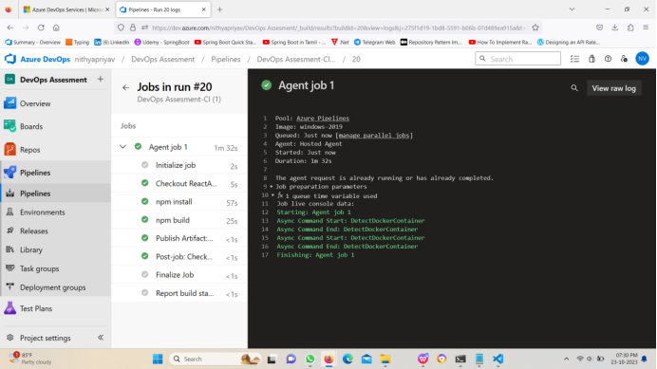

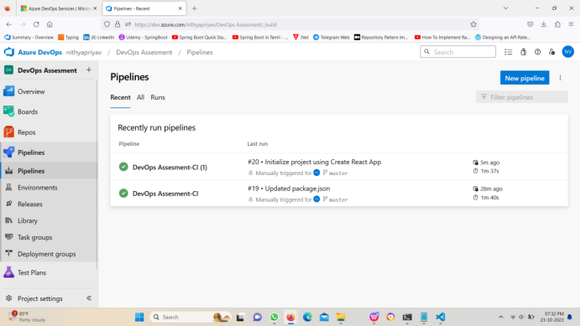

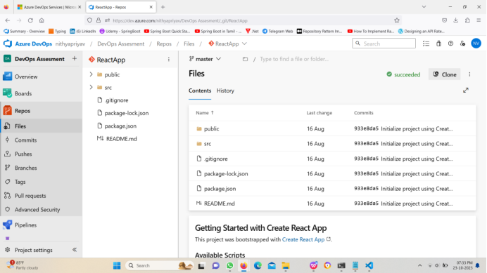

**Labs (For All Topics):**

**1. Lab: Azure DevOps Project Setup**

Objective: Create a new project in Azure DevOps and set up a sample

software development backlog.

Steps: Define user stories and tasks for a hypothetical project.

Step1: Create new project in Azure.

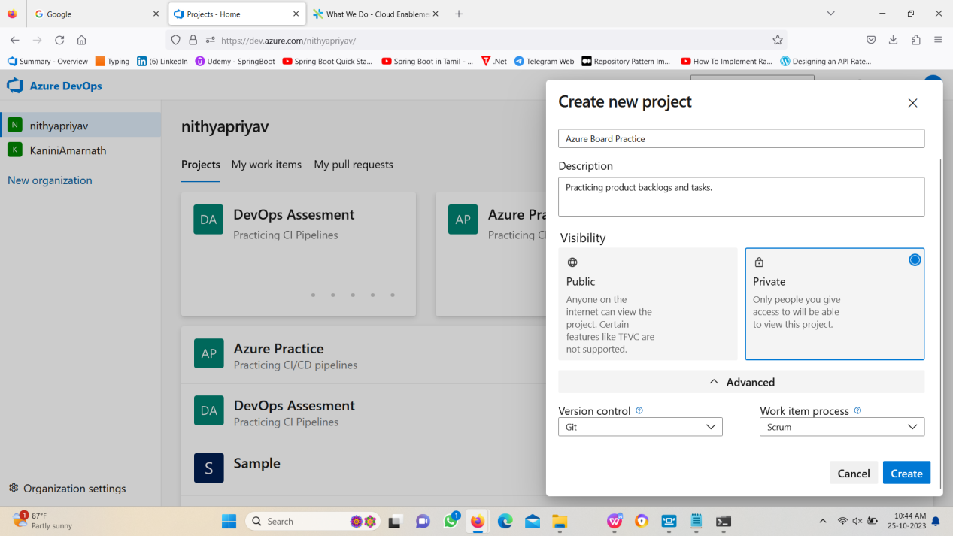

Step2: Then go to boards => Backlogs

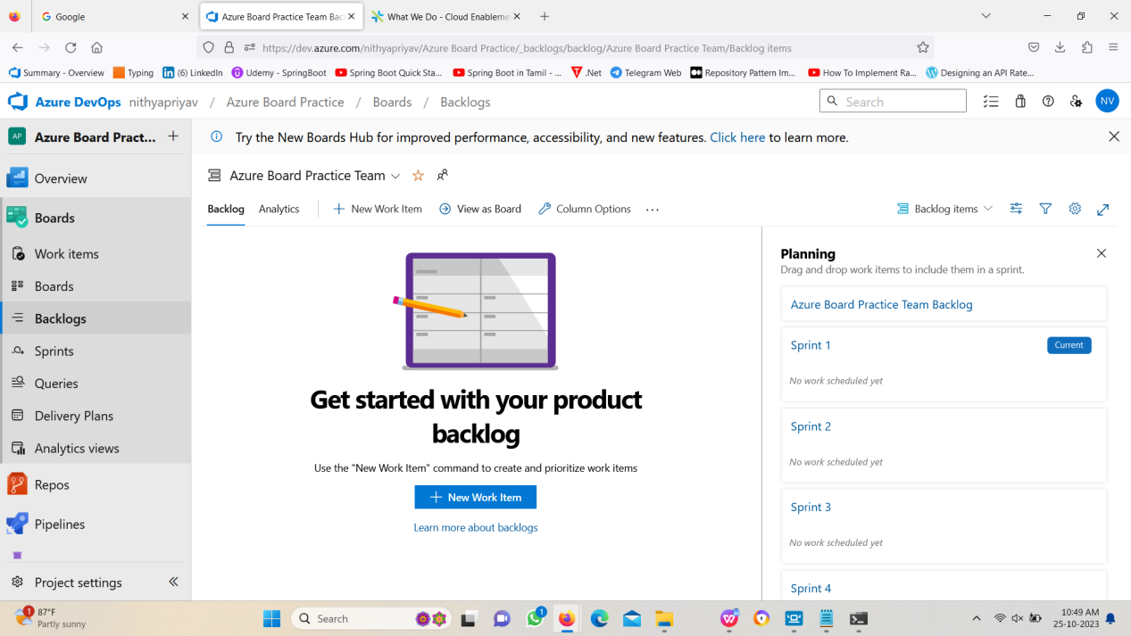

Step3: Create new Epic.

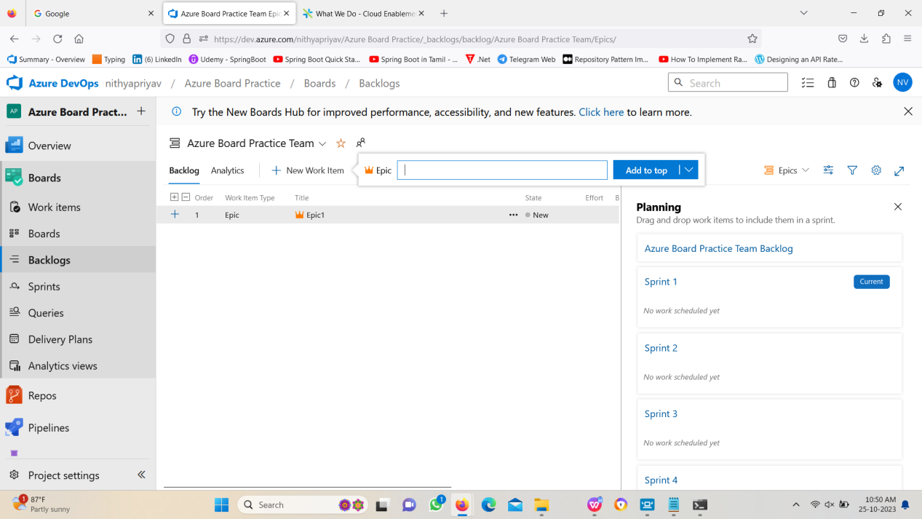

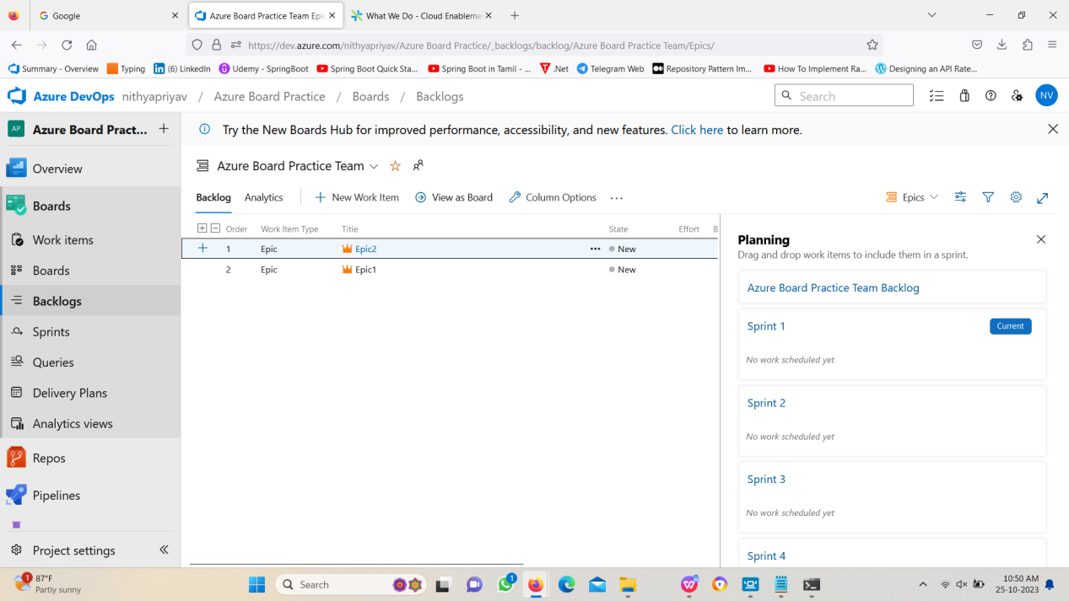

Step4: Create new feature under an epic.

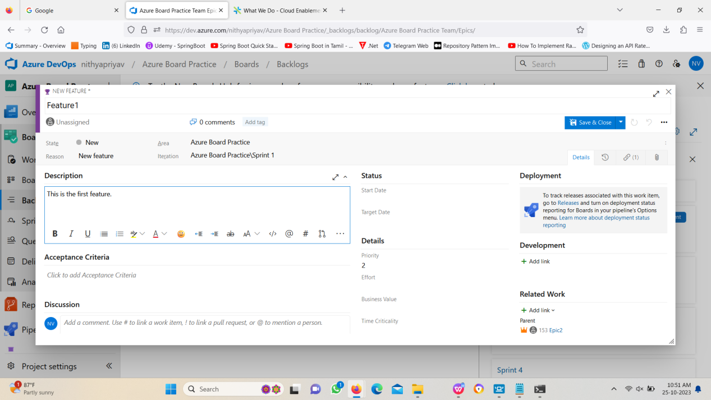

Step5: Create a product backlog item under a feature.

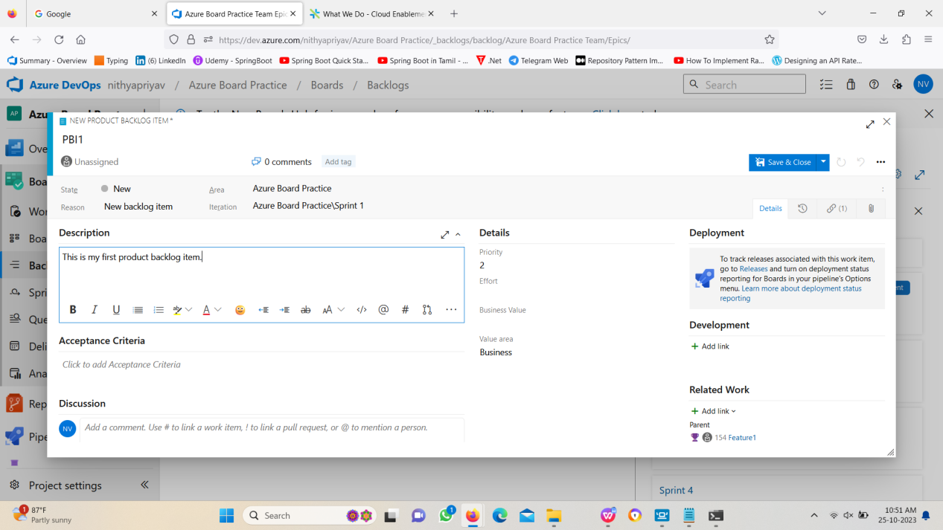

Step6: Create a task under the product backlog item.

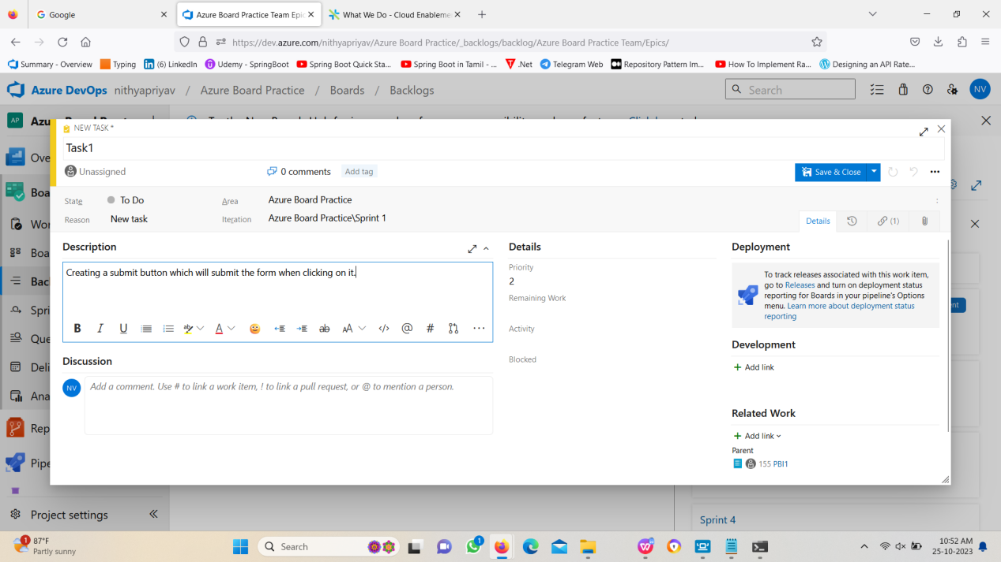

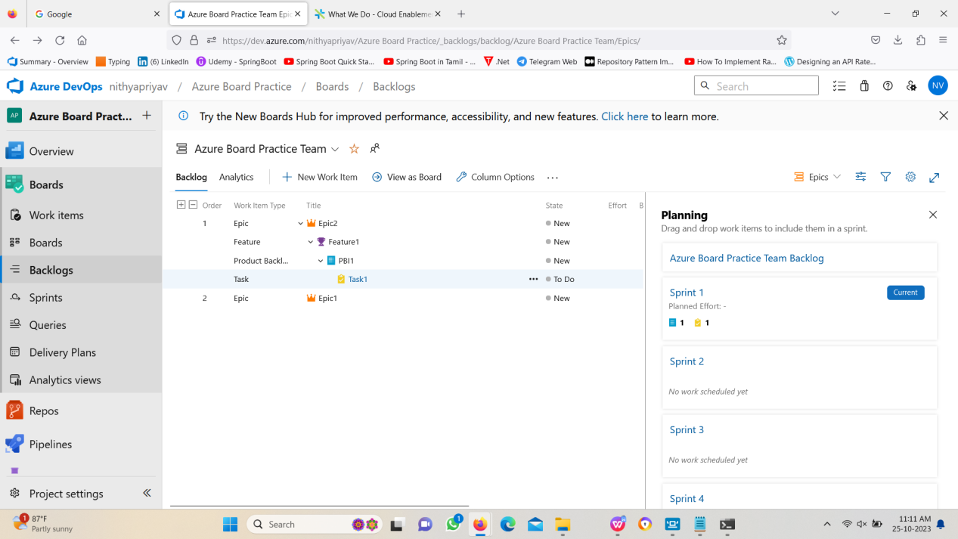

**2. Lab: Git Repository Setup**

Objective: Configure a Git repository in Azure DevOps to manage the source

code for your project using Visual Studio Code.

Steps: Create a Git repository, push code, and collaborate with team

members using command line.

Step1: Creating new project and create a new repository inside that project.

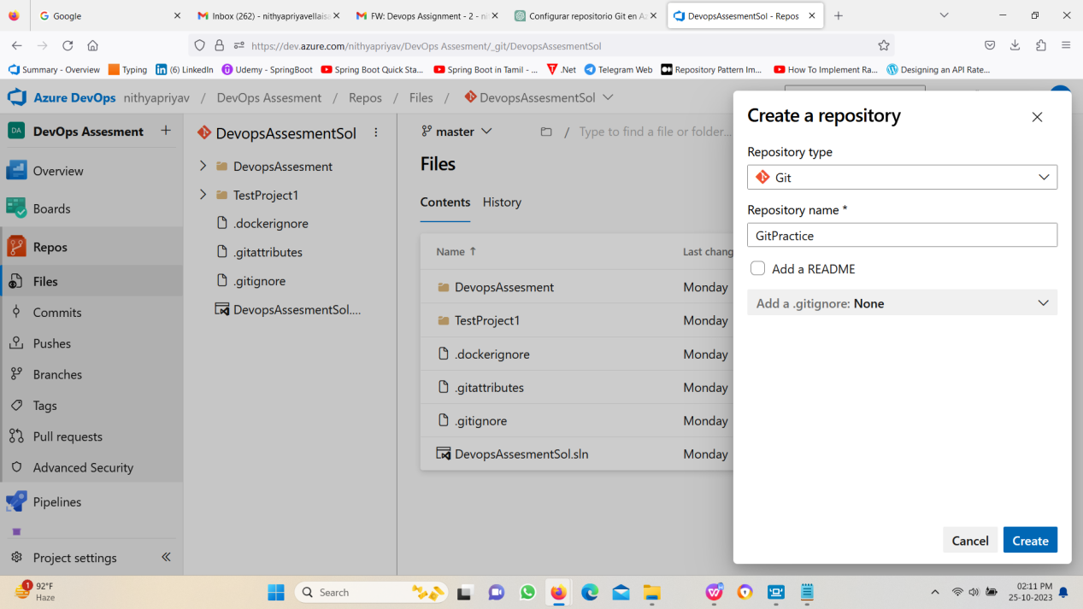

Step2: Copy the clone url in that page.

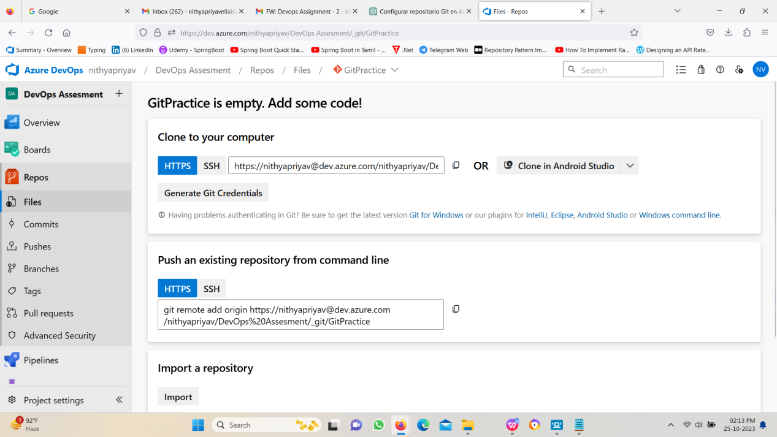

Step3: Open your command prompt where you want to store your project.

Using “git clone url”, clone the repository.

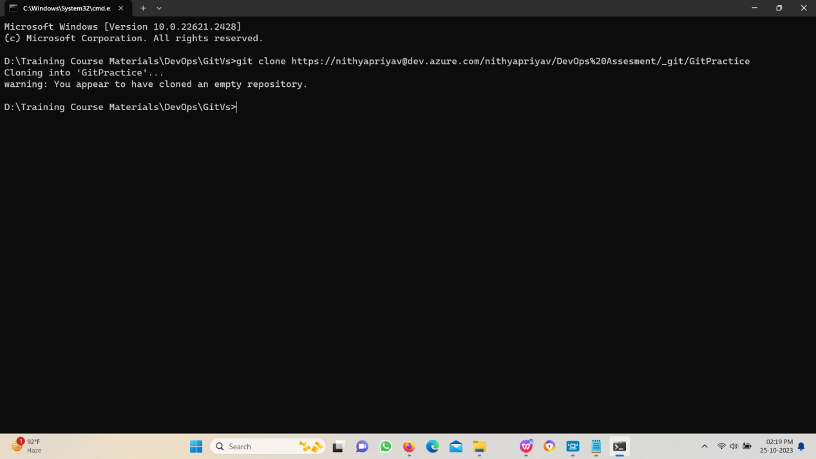

Step4: Open the folder in visual studio code.

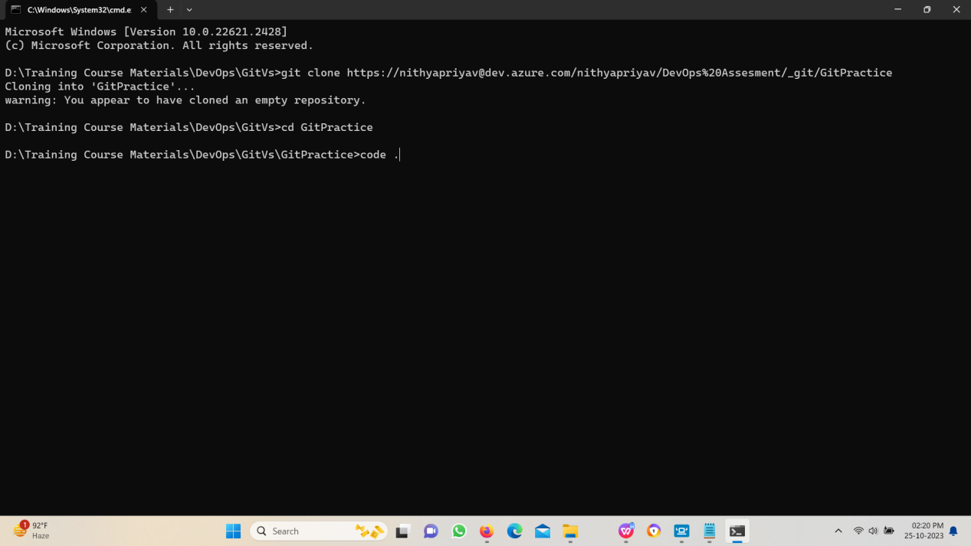

Step5: Create the project inside the folder or do the changes as the project needs.

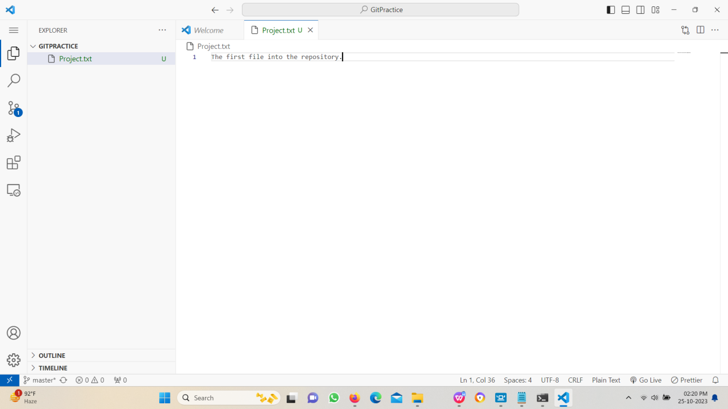

Step6: Add and commit the changes and then push it in the repository.

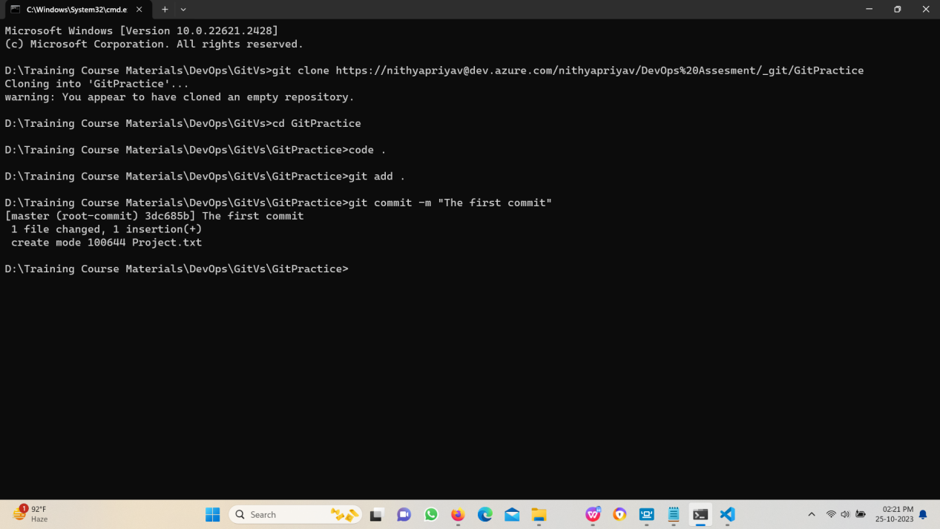

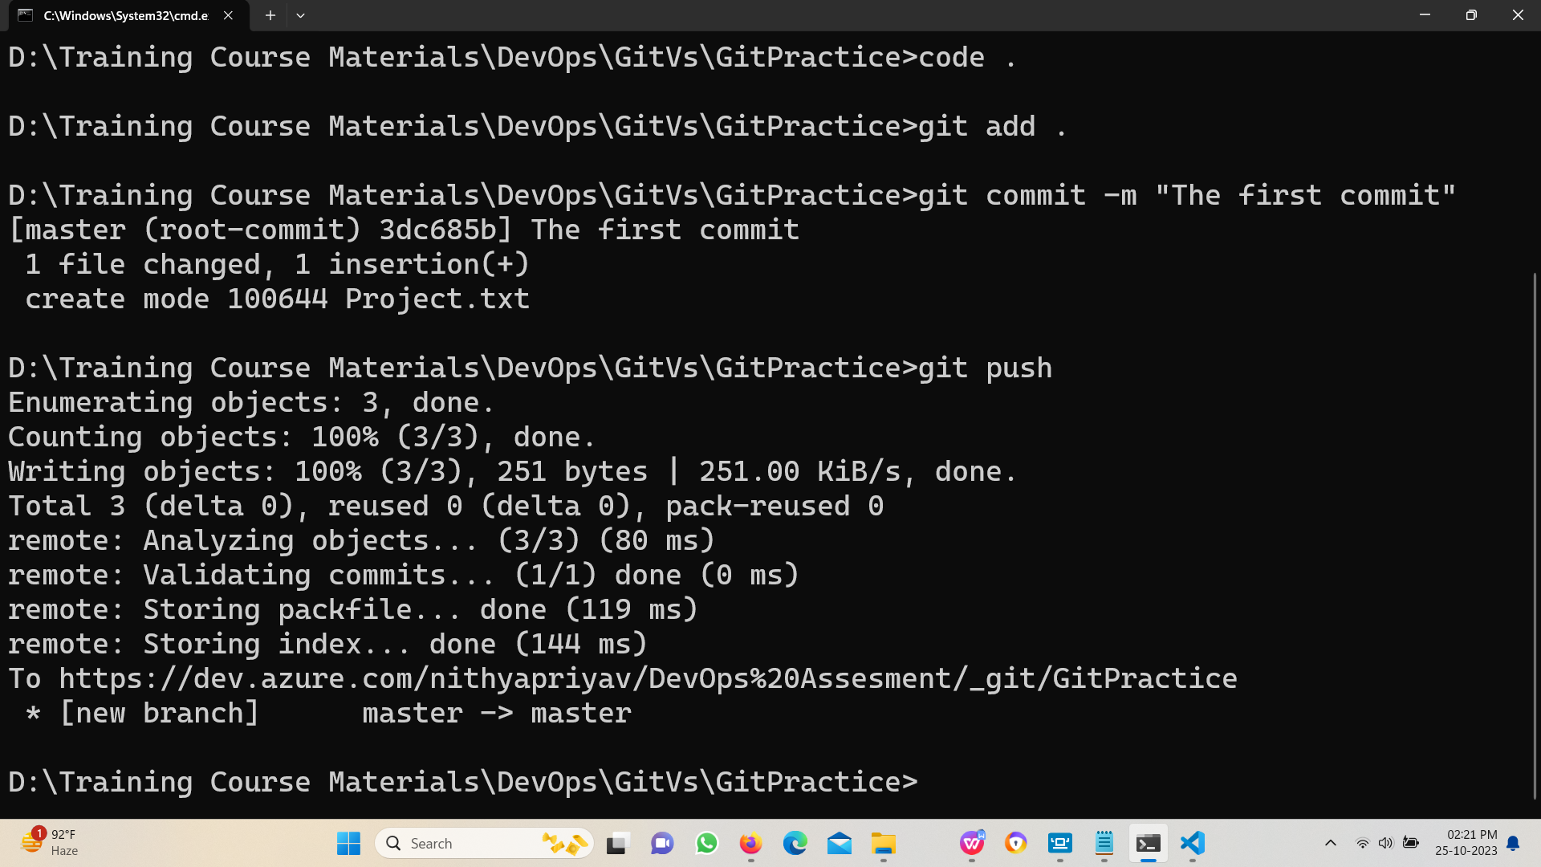

Check the code in the azure repository.

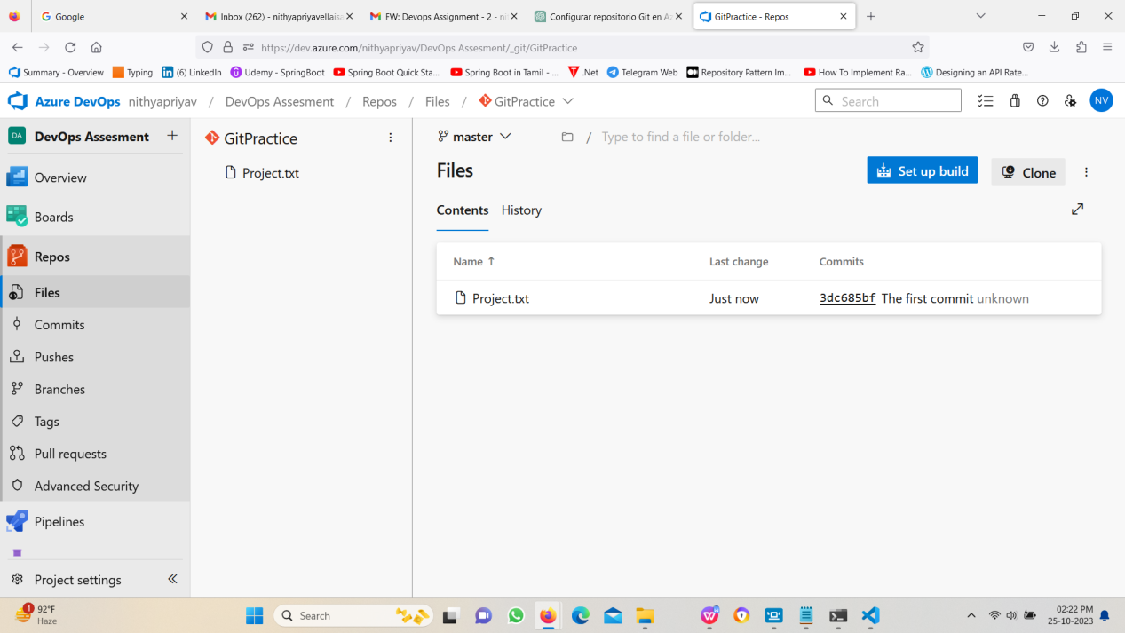

**3.Lab: CI for React Application:**

Create a build pipeline in Azure DevOps that compiles and packages a simple

application react application.

Step1: Creating a angular project and push it in a azure devops repository.



Step2: The angular project files are available in azure devops repository.



Step3: Creating a new pipeline with npm install, npm build and publish Artifacts.



Step4: Running the agent.







**4. Lab: CI for Angular Application:**

Create a build pipeline in Azure DevOps that compiles and packages a simple

application Angular application.

Step1: Create a new Angular application and push it in a azure git repository.

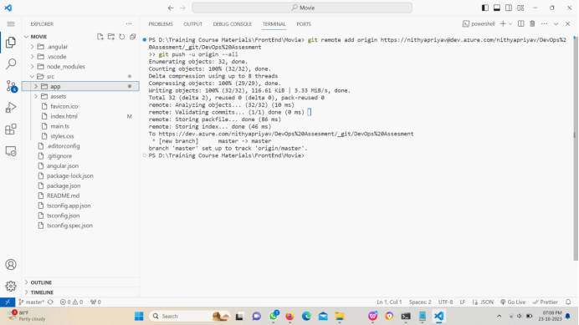

Step2: Creating a new pipeline with npm install, npm build and public artifacts.

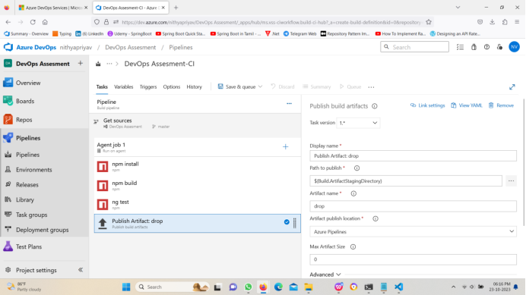

Step3: Running the agent.

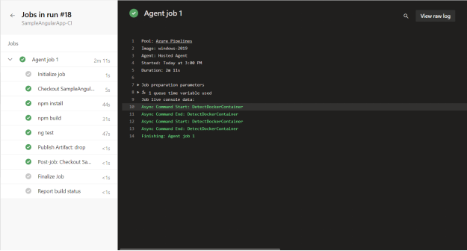

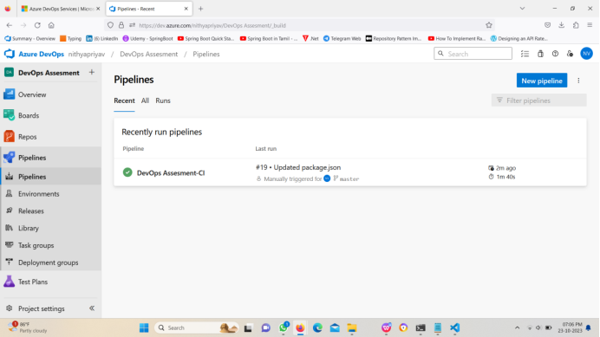

**5. Lab: CI for dotnet Core Application with MS Test unit:**

Create a build pipeline in Azure DevOps that compiles and packages a

simple application .NETCore application along with unit test.

Step1: Create a new .net core web API and push it in a azure git repository.

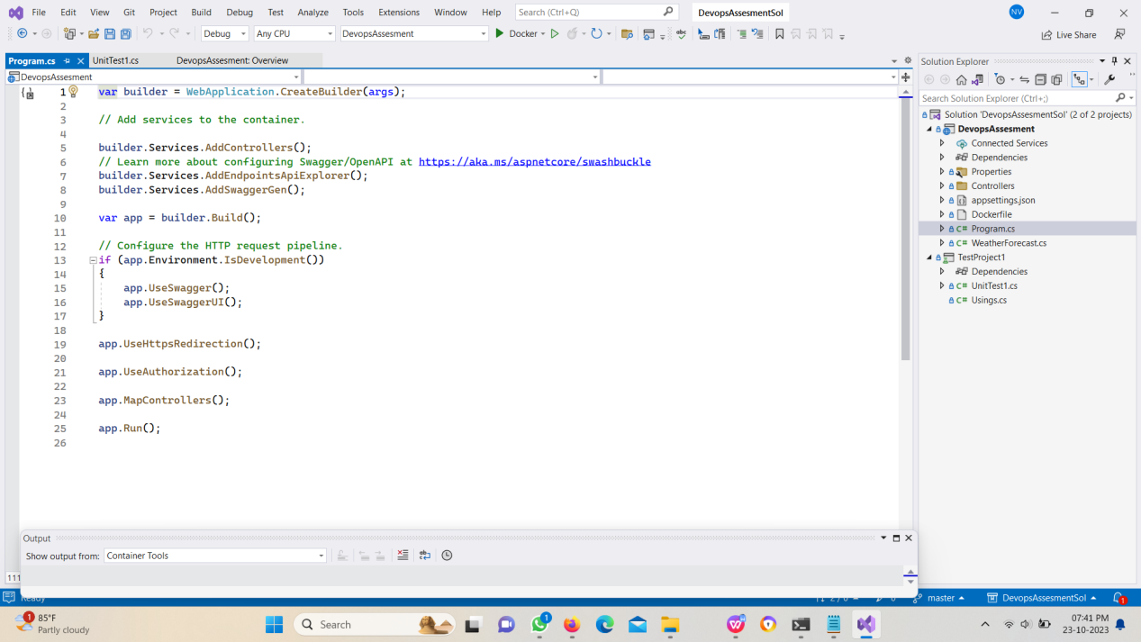

Step2: The files are available in the azure git repository.

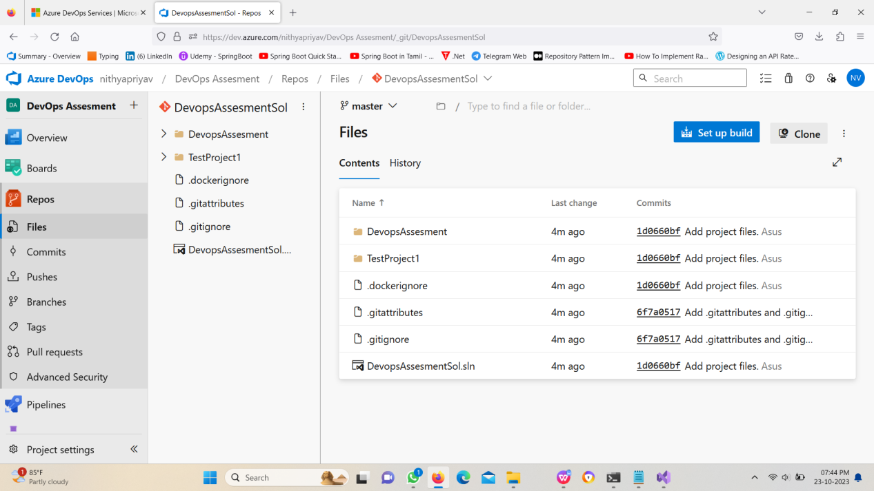

Step3: Creating a new CI pipeline with Restore, build, test, publish and publish artifact.

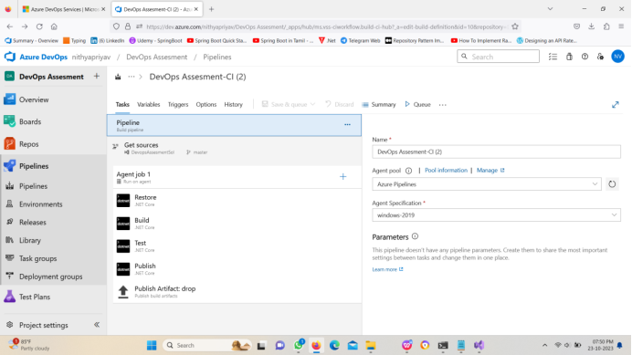

Step4: Running the Agent.

